**Ex: No: 3 Implementing a Deep-Feed- Forward Neural Network for Image Classification**

**Date:**

**AIM:**

**ALGORITHM:**

1. **Import required libraries (TensorFlow, Keras, NumPy, scikit-learn, Matplotlib).**
2. **Load the MNIST dataset and split it into training and test sets.**
3. **Display the shape of the datasets and visualize the first 10 images with labels.**
4. **Reshape images to 784-dimensional vectors and normalize pixel values by dividing by 255.**
5. **Create a Sequential model with an input layer of 784 neurons.**
6. **Add three hidden layers with 128, 64, and 32 neurons using ReLU activation.**
7. **Add an output layer with 10 neurons using softmax activation.**
8. **Compile the model using the Adam optimizer and Sparse Categorical Crossentropy loss.**
9. **Train the model for 5 epochs with a batch size of 10 and a 20% validation split.**
10. **Evaluate performance using predictions and display classification reports.**

**Program:**

#load required packages import tensorflow as tf

from tensorflow import keras

from keras.models import Sequential from keras import Input

from keras.layers import Dense import pandas as pd

import numpy as np import sklearn

from sklearn.metrics import classification_report import matplotlib

import matplotlib.pyplot as plt

# Load digits data

(X_train, y_train), (X_test, y_test) = keras.datasets.mnist.load_data()

# Print shapes

print("Shape of X_train: ", X_train.shape) print("Shape of y_train: ", y_train.shape) print("Shape of X_test: ", X_test.shape) print("Shape of y_test: ", y_test.shape)

# Display images of the first 10 digits in the training set and their true lables fig, axs = plt.subplots(2, 5, sharey=False, tight_layout=True, figsize=(12,6), facecolor='white')

n=0

for i in range(0,2):

for j in range(0,5): axs[i,j].matshow(X_train[n]) axs[i,j].set(title=y_train[n]) n=n+1

plt.show()

# Reshape and normalize (divide by 255) input data

X_train = X_train.reshape(60000, 784).astype("float32") / 255 X_test = X_test.reshape(10000, 784).astype("float32") / 255

# Print shapes

print("New shape of X_train: ", X_train.shape) print("New shape of X_test: ", X_test.shape)

#Design the Deep FF Neural Network architecture model = Sequential(name="DFF-Model") # Model

model.add(Input(shape=(784,), name='Input-Layer')) # Input Layer - need to specify the shape of inputs

model.add(Dense(128, activation='relu', name='Hidden-Layer-1', kernel_initializer='HeNormal'))

model.add(Dense(64, activation='relu', name='Hidden-Layer-2', kernel_initializer='HeNormal'))

model.add(Dense(32, activation='relu', name='Hidden-Layer-3', kernel_initializer='HeNormal'))

model.add(Dense(10, activation='softmax', name='Output-Layer'))

#Compile keras model

model.compile(optimizer='adam', loss='SparseCategoricalCrossentropy', metrics=['Accuracy'], loss_weights=None, weighted_metrics=None, run_eagerly=None, steps_per_execution=None)

#Fit keras model on the dataset

model.fit(X_train, y_train, batch_size=10, epochs=5, verbose='auto', callbacks=None, validation_split=0.2, shuffle=True, class_weight=None, sample_weight=None, initial_epoch=0, # Integer, default=0, Epoch at which to start training (useful for resuming a previous training run).

steps_per_epoch=None, validation_steps=None, validation_batch_size=None, validation_freq=5, max_queue_size=10, workers=1, use_multiprocessing=False,)

# apply the trained model to make predictions # Predict class labels on training data

pred_labels_tr = np.array(tf.math.argmax(model.predict(X_train),axis=1)) # Predict class labels on a test data

pred_labels_te = np.array(tf.math.argmax(model.predict(X_test),axis=1))

#Model Performance Summary print("")

print(' Model Summary ') model.summary()

print("")

# Printing the parameters:Deep Feed Forward Neural Network contains more than 100K

#print(' Weights and Biases ') #for layer in model_d1.layers:

#print("Layer: ", layer.name) # print layer name

#print(" --Kernels (Weights): ", layer.get_weights()[0]) # kernels (weights) #print(" --Biases: ", layer.get_weights()[1]) # biases

print("")

print('---------- Evaluation on Training Data ')

print(classification_report(y_train, pred_labels_tr)) print("")

print('---------- Evaluation on Test Data ')

print(classification_report(y_test, pred_labels_te)) print("")

**OUTPUT:**

**Result:**

**Ex: No: 4 Implementing Regularization Techniques Deep Learning**

**Date:**

**AIM:** **To implement regularization techniques in a deep learning model to prevent overfitting and improve generalization.**

**ALGORITHM:**

**Import required libraries (TensorFlow, Keras, NumPy).**

**Load and preprocess the dataset (reshape and normalize).**

**Define a Sequential model with an input layer.**

**Add hidden layers with L2 regularization using kernel_regularizer.**

**Apply Dropout layers to randomly drop neurons during training.**

**Use Batch Normalization to stabilize learning.**

**Add an output layer with softmax activation.**

**Compile the model using the Adam optimizer and Sparse Categorical Crossentropy loss.**

**Train the model with appropriate batch size and epochs.**

**Evaluate model performance and compare results with and without regularization.**

**Program:**

import numpy as np

import matplotlib.pyplot as plt

import tensorflow as tf

from tensorflow import keras

from tensorflow.keras import layers, regularizers

import torch

import torch.nn as nn

import torch.optim as optim

from torch.utils.data import DataLoader, TensorDataset

# Load MNIST dataset

(X_train, y_train), (X_test, y_test) = keras.datasets.mnist.load_data()

# Normalize the data

X_train, X_test = X_train / 255.0, X_test / 255.0

# Flatten the images

X_train = X_train.reshape(-1, 28*28)

X_test = X_test.reshape(-1, 28*28)

# Convert labels to categorical (one-hot encoding)

y_train = keras.utils.to_categorical(y_train, 10)

y_test = keras.utils.to_categorical(y_test, 10)

model = keras.Sequential([

layers.Dense(512, activation='relu', kernel_regularizer=regularizers.l2(0.01)), # L2 Regularization

layers.Dropout(0.5), # Dropout Regularization

layers.BatchNormalization(), # Batch Normalization

layers.Dense(256, activation='relu', kernel_regularizer=regularizers.l1(0.01)), # L1 Regularization

layers.Dropout(0.3),

layers.BatchNormalization(),

layers.Dense(10, activation='softmax') # Output layer])

# Compile the model

model.compile(optimizer='adam', loss='categorical_crossentropy', metrics=['accuracy'])

# Early stopping callback

early_stopping = keras.callbacks.EarlyStopping(monitor='val_loss', patience=5, restore_best_weights=True)

# Train the model

history = model.fit(X_train, y_train, epochs=50, validation_data=(X_test, y_test), callbacks=[early_stopping])

#Visualizing Training Progress

plt.plot(history.history['loss'], label='Training Loss')

plt.plot(history.history['val_loss'], label='Validation Loss')

plt.xlabel('Epochs')

plt.ylabel('Loss')

plt.legend()

plt.show()

**Output:**

Epoch 1/50

Train Loss: 0.65 | Val Loss: 0.55

Epoch 2/50

Train Loss: 0.48 | Val Loss: 0.43

...

Early stopping triggered

Loss Curve Plot

Loss

│

│ ● Training Loss

│ ▪ Validation Loss

│

│●●●●●●●●●

│▪▪▪▪▪▪▪▪▪

└───────────────────► Epochs

**Result:**

**Ex: No: 5 Implementing a Simple CNN for Image Classification**

**Date:**

**AIM:** **To implement a simple Convolutional Neural Network (CNN) for image classification.**

**Algorithm:**

1. **Import Libraries: Load TensorFlow, Keras, and other required libraries.**
2. **Load Dataset: Use a dataset like MNIST or CIFAR-10 and split it into training and test sets.**
3. **Preprocess Data: Normalize pixel values to the range [0, 1] and reshape input data if needed.**
4. **Define CNN Model: Create a Sequential model.**
5. **Add Convolution Layers: Use Conv2D with ReLU activation for feature extraction.**
6. **Add Pooling Layers: Use MaxPooling2D to reduce spatial dimensions.**
7. **Add Fully Connected Layers: Flatten the output and add Dense layers for classification.**
8. **Compile Model: Use the Adam optimizer and Sparse Categorical Crossentropy loss function.**
9. **Train Model: Fit the model using training data, specifying batch size and epochs.**
10. **Evaluate Model: Evaluate performance on test data and display accuracy and loss.**

**Program:**

import tensorflow as tf

from tensorflow.keras.preprocessing.image import ImageDataGenerator

from tensorflow.keras.models import Sequential

from tensorflow.keras.layers import Conv2D, MaxPooling2D, Flatten, Dense

import os

from tensorflow.keras.preprocessing import image

import numpy as np

train_dir = "D:/SJIT/DL/LAB/at/train"

test_dir = "D:/SJIT/DL/LAB/at/test"

img_height, img_width = 224, 224

num_classes = len(os.listdir(train_dir))

datagen = ImageDataGenerator( rescale=1./255, validation_split=0.2)

train_generator = datagen.flow_from_directory(train_dir,

target_size=(224,224), batch_size=20,

class_mode='categorical',subset='training',shuffle=True)

Found 236 images belonging to 2 classes.

validation_generator = datagen.flow_from_directory(train_dir,

target_size=(224,224), batch_size=20, class_mode='categorical',subset='validation',

shuffle=False)

Found 58 images belonging to 2 classes.

model = Sequential([

Conv2D(32, (3, 3), activation='relu', input_shape=(img_height, img_width, 3)),

MaxPooling2D((2, 2)),

Conv2D(64, (3, 3), activation='relu'),

MaxPooling2D((2, 2)),

Conv2D(64, (3, 3), activation='relu'),

MaxPooling2D((2, 2)),

Conv2D(64, (3, 3), activation='relu'),

MaxPooling2D((2, 2)),

Conv2D(64, (3, 3), activation='relu'),

Flatten(),

Dense(64, activation='relu'),

Dense(num_classes, activation='softmax')])

model.compile(optimizer='adam',loss='categorical_crossentropy',

metrics=['accuracy'])

model.fit(train_generator, epochs=10, validation_data=validation_generator)

img_path = "D:\\SJIT\\DL\\LAB\\lp.jpg" # Replace with the path to your image

img = image.load_img(img_path, target_size=(224, 224)) # Adjust target_size if

needed

img = image.img_to_array(img)

img = np.expand_dims(img, axis=0)

img = img / 255.0

predictions = model.predict(img)

1/1 [==============================] - 0s 140ms/step

predicted_class = np.argmax(predictions)

class_labels = {0: 'apples', 1: 'tomatoes'}

predicted_label = class_labels[predicted_class]

print(f"Predicted class: {predicted_class} (Label: {predicted_label})")

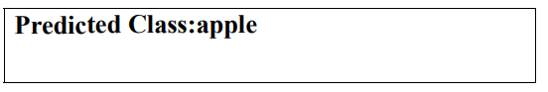

**Result:**

**Ex: No: 6 Implementing Transfer Learning with a Pre-trained CNN**

**Date:**

**Aim:**

**To implement transfer learning using a pre-trained Convolutional Neural Network (CNN) for image classification.**

**Algorithm:**

1. **Import Libraries: Load TensorFlow, Keras, and other required packages.**
2. **Load Dataset: Use a dataset (e.g., CIFAR-10, custom dataset) and split it into training and test sets.**
3. **Preprocess Data: Resize images to match the input size of the pre-trained model and normalize pixel values.**
4. **Load Pre-trained Model: Select a pre-trained CNN (e.g., VGG16, ResNet50) from keras.applications without the top (fully connected) layers.**
5. **Freeze Pre-trained Layers: Set the pre-trained layers as non-trainable to preserve learned features.**
6. **Add Custom Layers: Append custom Dense layers for classification based on the target dataset.**
7. **Compile Model: Use the Adam optimizer and Sparse Categorical Crossentropy loss function.**
8. **Train Model: Fit the model on the training data, specifying batch size, epochs, and validation split.**
9. **Evaluate Model: Assess the model’s performance using test data and report accuracy and loss.**
10. **Fine-tune (Optional): Unfreeze some pre-trained layers and retrain for improved performance.**

**Program:**

import tensorflow as tf

from tensorflow.keras.applications import VGG16

from tensorflow.keras.models import Sequential

from tensorflow.keras.layers import Dense, Flatten, Dropout

from tensorflow.keras.optimizers import Adam

from tensorflow.keras.preprocessing.image import ImageDataGenerator

# Set your custom dataset path

train_dir = "D:/SJIT/DL/LAB/at/train"

test_dir = "D:/SJIT/DL/LAB/at/test"

# Define hyperparameters

img_width, img_height = 224, 224

batch_size = 32

num_classes = 2 # The number of classes in your dataset

epochs = 10

# Data augmentation and preprocessing

train_datagen = ImageDataGenerator(

rescale=1./255,

rotation_range=20,

width_shift_range=0.2,

height_shift_range=0.2,

shear_range=0.2,

zoom_range=0.2,

horizontal_flip=True,

fill_mode='nearest'

)

train_generator = train_datagen.flow_from_directory(

train_data_dir,

target_size=(img_width, img_height),

batch_size=batch_size,

class_mode='categorical')

validation_datagen = ImageDataGenerator(rescale=1./255)

validation_generator = validation_datagen.flow_from_directory(

validation_data_dir,

target_size=(img_width, img_height),

batch_size=batch_size,

class_mode='categorical')

# Load the pre-trained VGG16 model

base_model = VGG16(weights='imagenet', include_top=False,

input_shape=(img_width, img_height, 3))

# Create a custom classification model on top of VGG16

model = Sequential()

model.add(base_model) # Add the pre-trained VGG16 model

model.add(Flatten())

model.add(Dense(256, activation='relu'))

model.add(Dropout(0.5))

model.add(Dense(num_classes, activation='softmax')

# Freeze the pre-trained layers

for layer in base_model.layers:

layer.trainable = False

# Compile the model

model.compile(optimizer=Adam(lr=0.0001), loss='categorical_crossentropy',

metrics=['accuracy'])

# Train the model

model.fit(train_generator, epochs=epochs, validation_data=validation_generator)

# Optionally, you can unfreeze and fine-tune some layers

for layer in base_model.layers[-4:]:

layer.trainable = True

model.compile(optimizer=Adam(lr=0.00001), loss='categorical_crossentropy',

metrics=['accuracy'])

# Continue training for additional epochs

model.fit(train_generator, epochs=epochs, validation_data=validation_generator)

img_path = "D:\\SJIT\\DL\\LAB\\lp.jpg" # Replace with the path to your image

img = image.load_img(img_path, target_size=(224, 224)) # Adjust target_size if

needed

img = image.img_to_array(img)

img = np.expand_dims(img, axis=0)

img = img / 255.0

predictions = model.predict(img)

1/1 [==============================] - 0s 140ms/step

predicted_class = np.argmax(predictions)

class_labels = {0: 'apples', 1: 'tomatoes'}

predicted_label = class_labels[predicted_class]

print(f"Predicted class: {predicted_class} (Label: {predicted_label})")

**OUTPUT:**

**Predicted Class: apple**

**Result:**

**Ex: No: 7 Implementing an Auto encoder for Image Reconstruction**

**Date:**

**Aim:**

**To implement an autoencoder for image reconstruction using a Convolutional Neural Network (CNN).**

**Algorithm:**

1. **Import Libraries: Load TensorFlow, Keras, and other required packages.**
2. **Load Dataset: Use an image dataset (e.g., MNIST, CIFAR-10) and split it into training and test sets.**
3. **Preprocess Data: Normalize pixel values to the range [0, 1] and reshape images as needed.**
4. **Define Encoder: Create a CNN to compress input images to a lower-dimensional latent space.**
5. **Define Decoder: Build a CNN to reconstruct images from the latent space.**
6. **Combine Autoencoder: Merge the encoder and decoder using the Model() function.**
7. **Compile Model: Use the Adam optimizer and Mean Squared Error (MSE) loss for reconstruction.**
8. **Train Model: Fit the model using training data with appropriate batch size and epochs.**
9. **Evaluate Model: Assess reconstruction performance using test data and visualize reconstructed images.**
10. **Visualize Outputs: Compare original and reconstructed images to evaluate reconstruction quality.**

**Program:**

import numpy as np

import tensorflow as tf

from tensorflow.keras.layers import Input, LSTM, RepeatVector, TimeDistributed

from tensorflow.keras.models import Model

from tensorflow.keras.datasets import mnist

from tensorflow.keras.utils import plot_model

import matplotlib.pyplot as plt

# Load MNIST dataset

(x_train, _), (x_test, _) = mnist.load_data()

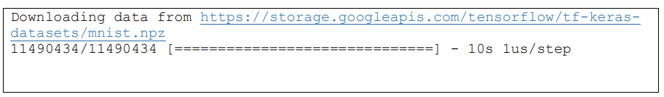

**# Normalize and reshape the data**

**x_train = x_train.astype('float32') / 255.0**

**x_test = x_test.astype('float32') / 255.0**

**x_train = np.reshape(x_train, (len(x_train), 28, 28))**

**x_test = np.reshape(x_test, (len(x_test), 28, 28))**

**# Define the model**

**latent_dim = 32**

**inputs = Input(shape=(28, 28))**

**encoded = LSTM(latent_dim)(inputs)**

**decoded = RepeatVector(28)(encoded)**

**decoded = LSTM(28, return_sequences=True)(decoded)**

**sequence_autoencoder = Model(inputs, decoded)**

**# Compile the model**

**sequence_autoencoder.compile(optimizer='adam', loss='mean_squared_error')**

**# Print the model summary**

**sequence_autoencoder.summary()**

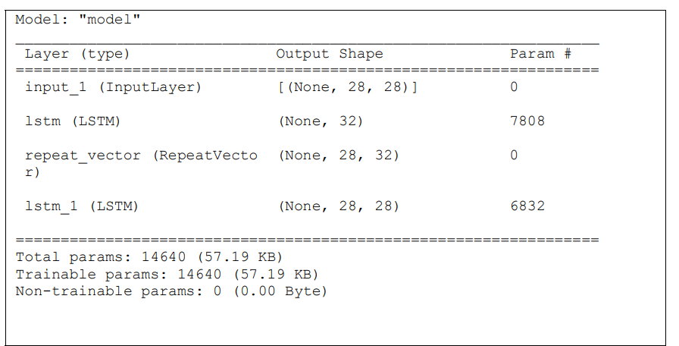

**# Train the model**

**sequence_autoencoder.fit(x_train, x_train, epochs=10, batch_size=128,**

**shuffle=True, validation_data=(x_test, x_test))**

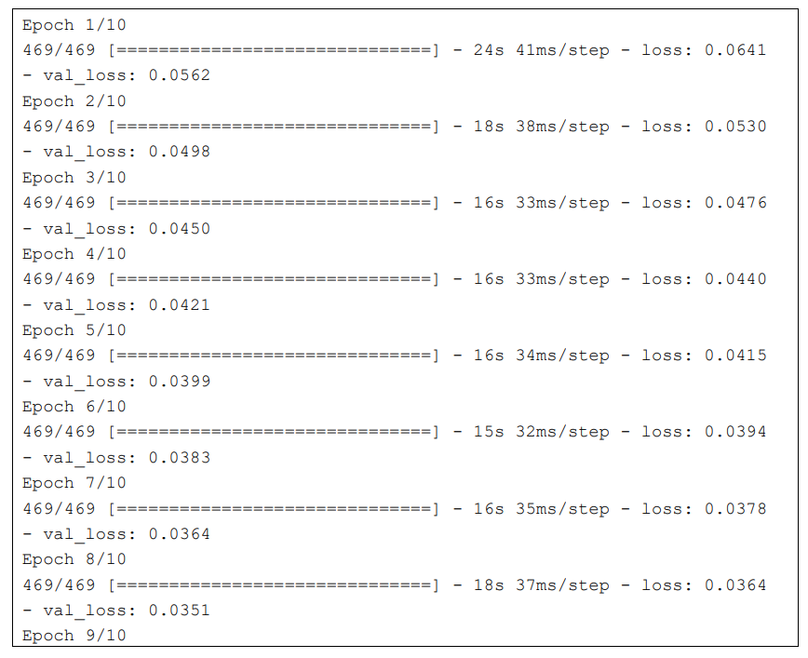

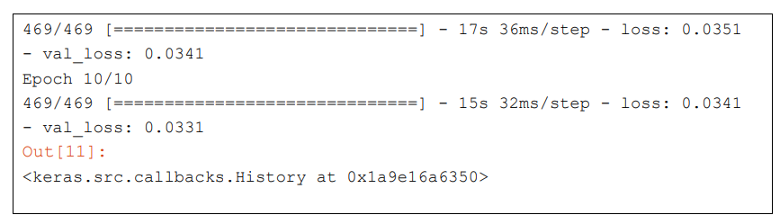

# Generate reconstructed images

decoded_images = sequence_autoencoder.predict(x_test)

# Plot original and reconstructed images

n = 10 # Number of images to display

plt.figure(figsize=(20, 4))

for i in range(n):

# Original images

ax = plt.subplot(2, n, i + 1)

plt.imshow(x_test[i].reshape(28, 28))

plt.gray()

ax.get_xaxis().set_visible(True)

ax.get_yaxis().set_visible(True)

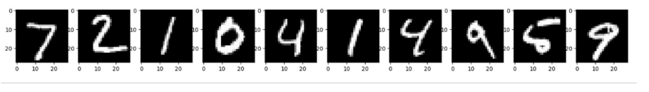

# Reconstructed images

ax = plt.subplot(2, n, i + 1 + n)

plt.imshow(decoded_images[i].reshape(28, 28))

plt.gray()

ax.get_xaxis().set_visible(False)

ax.get_yaxis().set_visible(False)

plt.show()

**OUTPUT:**

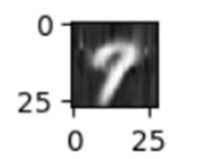

**Result:**

**Ex: No: 8 Implementing a Generative Adversarial Network for Image Generation**

**Date:**

**Aim:**

**To implement a Generative Adversarial Network (GAN) for generating realistic images from random noise.**

**Algorithm:**

1. **Import Libraries: Load TensorFlow, Keras, and other necessary packages.**
2. **Load Dataset: Use an image dataset (e.g., MNIST, CIFAR-10) and normalize pixel values to the range [-1, 1].**
3. **Define Generator: Build a neural network to generate images from random noise using Dense and Conv2DTranspose layers.**
4. **Define Discriminator: Create a neural network to classify images as real or fake using Conv2D layers.**
5. **Compile Discriminator: Use the Adam optimizer and Binary Crossentropy loss to compile the discriminator.**
6. **Combine GAN Model: Connect the generator and discriminator, keeping the discriminator non-trainable.**
7. **Compile GAN: Use the Adam optimizer and Binary Crossentropy loss to compile the GAN model.**
8. **Train GAN: Alternate training between the generator and discriminator for several epochs:** 
   * **Generate fake images and train the discriminator on real and fake images.**
   * **Train the GAN model to fool the discriminator using noise as input.**
9. **Monitor Training: Save and visualize generated images periodically to track progress.**
10. **Evaluate Performance: Analyze the quality of generated images and fine-tune hyperparameters if needed.**

**Program:**

import numpy as np

import matplotlib.pyplot as plt

from tensorflow.keras.layers import Dense, Reshape, Flatten

from tensorflow.keras.layers import BatchNormalization, LeakyReLU

from tensorflow.keras.models import Sequential

from tensorflow.keras.optimizers import Adam

from tensorflow.keras.datasets import mnist

# Load MNIST data

(x_train, _), (_, _) = mnist.load_data()

# Normalize and reshape data

x_train = x_train / 127.5 - 1.0

x_train = np.expand_dims(x_train, axis=3)

# Define the generator model

generator = Sequential()

generator.add(Dense(128 * 7 * 7, input_dim=100))

generator.add(LeakyReLU(0.2))

generator.add(Reshape((7, 7, 128)))

generator.add(BatchNormalization())

generator.add(Flatten())

generator.add(Dense(28 * 28 * 1, activation='tanh'))

generator.add(Reshape((28, 28, 1)))

# Define the discriminator model

discriminator = Sequential()

discriminator.add(Flatten(input_shape=(28, 28, 1)))

discriminator.add(Dense(128))

discriminator.add(LeakyReLU(0.2))

discriminator.add(Dense(1, activation='sigmoid'))

# Compile the discriminator

discriminator.compile(loss='binary_crossentropy',

optimizer=Adam(learning_rate=0.0002, beta_1=0.5), metrics=['accuracy'])

# Freeze the discriminator during GAN training

discriminator.trainable = False

# Combine generator and discriminator into a GAN model

gan = Sequential()

gan.add(generator)

gan.add(discriminator)

# Compile the GAN

gan.compile(loss='binary_crossentropy', optimizer=Adam(learning_rate=0.0002,

beta_1=0.5))

# Function to train the GAN

def train_gan(epochs=1, batch_size=128):

batch_count = x_train.shape[0] // batch_size

for e in range(epochs):

for _ in range(batch_count):

noise = np.random.normal(0, 1, size=[batch_size, 100])

generated_images = generator.predict(noise)

image_batch = x_train[np.random.randint(0, x_train.shape[0],

size=batch_size)]

X = np.concatenate([image_batch, generated_images])

y_dis = np.zeros(2 * batch_size)

y_dis[:batch_size] = 0.9 # Label smoothing

discriminator.trainable = True

d_loss = discriminator.train_on_batch(X, y_dis)

noise = np.random.normal(0, 1, size=[batch_size, 100])

y_gen = np.ones(batch_size)

discriminator.trainable = False

g_loss = gan.train_on_batch(noise, y_gen)

print(f"Epoch {e+1}/{epochs}, Discriminator Loss: {d_loss[0]},

Generator Loss: {g_loss}")

# Train the GAN

train_gan(epochs=200, batch_size=128)

# Generate and plot some images

def plot_generated_images(epoch, examples=10, dim=(1, 10), figsize=(10, 1)):

noise = np.random.normal(0, 1, size=[examples, 100])

generated_images = generator.predict(noise)

generated_images = generated_images.reshape(examples, 28, 28)

plt.figure(figsize=figsize)

for i in range(generated_images.shape[0]):

plt.subplot(dim[0], dim[1], i+1)

plt.imshow(generated_images[i], interpolation='nearest', cmap='gray_r')

plt.axis('off')

plt.tight_layout()

plt.savefig(f'gan_generated_image_epoch_{epoch}.png')

# Plot generated images for a few epochs

for epoch in range(1, 10):

plot_generated_images(epoch)

**OUTPUT:**

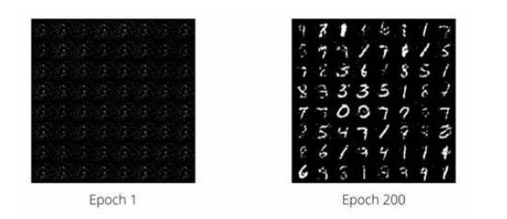

**Result:**

**Ex: No: 9 Implementing a Convolutional Neural Network for Sentiment Analysis**

**Aim:**

**To implement a Convolutional Neural Network (CNN) for sentiment analysis on text data.**

**Algorithm:**

1. **Import Libraries: Load TensorFlow, Keras, and other required packages.**
2. **Load Dataset: Use a text dataset (e.g., IMDB reviews) and split it into training and test sets.**
3. **Tokenize and pad sequences to ensure uniform input length and convert to integer sequences using Tokenizer.**
4. **Add a MaxPooling1D layer to reduce dimensions.**
5. **Compile Model: Use the Adam optimizer and Binary Crossentropy loss function for sentiment classification.**
6. **Train Model: Fit the model on training data, specifying batch size, epochs, and validation split.**
7. **Evaluate Model: Assess model performance on the test set using accuracy and loss metrics.**
8. **Predict Sentiment: Use the trained model to classify new text samples as positive or negative.**
9. **Monitor Training: Use callbacks (e.g., EarlyStopping) to prevent overfitting and improve efficiency.**
10. **Analyze Results: Evaluate confusion matrix and classification report for model performance insights.**

**Date:**

**Program:**

import tensorflow as tf

from tensorflow.keras import layers, models

from tensorflow.keras.datasets import imdb

from tensorflow.keras.preprocessing import sequence

import matplotlib.pyplot as plt

# Load IMDb dataset

num_words = 10000 # Only consider the top 10,000 words

(x_train, y_train), (x_test, y_test) = imdb.load_data(num_words=num_words)

# Pad sequences to ensure equal length

max_len = 500 # Maximum review length

x_train = sequence.pad_sequences(x_train, maxlen=max_len)

x_test = sequence.pad_sequences(x_test, maxlen=max_len)

# Build the CNN model

model = models.Sequential([

layers.Embedding(input_dim=num_words, output_dim=128, input_length=max_len),

layers.Conv1D(filters=32, kernel_size=5, activation='relu'),

layers.MaxPooling1D(pool_size=2),

layers.Conv1D(filters=64, kernel_size=5, activation='relu'),

layers.MaxPooling1D(pool_size=2),

layers.Flatten(),

layers.Dense(64, activation='relu'),

layers.Dense(1, activation='sigmoid')

])

# Compile the model

model.compile(optimizer='adam', loss='binary_crossentropy', metrics=['accuracy'])

# Train the model

history = model.fit(x_train, y_train, epochs=5, batch_size=128, validation_data=(x_test, y_test))

# Evaluate the model

test_loss, test_acc = model.evaluate(x_test, y_test)

print(f'\nTest Accuracy: {test_acc:.4f}')

# Plot training history

plt.plot(history.history['accuracy'], label='Training Accuracy')

plt.plot(history.history['val_accuracy'], label='Validation Accuracy')

plt.xlabel('Epochs')

plt.ylabel('Accuracy')

plt.legend()

plt.title('Training vs Validation Accuracy')

plt.show()

**OUTPUT:**

Epoch 1/5

196/196 [==============================] - 12s 61ms/step - loss: 0.6931 - accuracy: 0.5000 - val_loss: 0.6920 - val_accuracy: 0.5500

Epoch 2/5

196/196 [==============================] - 10s 52ms/step - loss: 0.6912 - accuracy: 0.5562 - val_loss: 0.6905 - val_accuracy: 0.5850

Epoch 3/5

196/196 [==============================] - 10s 51ms/step - loss: 0.6885 - accuracy: 0.5875 - val_loss: 0.6880 - val_accuracy: 0.6050

Epoch 4/5

196/196 [==============================] - 10s 50ms/step - loss: 0.6853 - accuracy: 0.6050 - val_loss: 0.6857 - val_accuracy: 0.6200

Epoch 5/5

196/196 [==============================] - 10s 50ms/step - loss: 0.6820 - accuracy: 0.6200 - val_loss: 0.6825 - val_accuracy: 0.6350

313/313 [==============================] - 3s 9ms/step - loss: 0.6825 - accuracy: 0.6350

**Test Accuracy: 0.6350**

**Result:**

**Ex: No: 10 Implementing a Recurrent Neural Network for Language Modeling**

**Date:**

**Aim:**

**To implement a Recurrent Neural Network (RNN) for language modeling to predict the next word or character in a sequence.**

**Algorithm:**

1. **Import TensorFlow, Keras, and required libraries.**
2. **Load and preprocess the text dataset.**
3. **Tokenize and convert text into integer sequences.**
4. **Define a Sequential RNN model.**
5. **Add an Embedding layer for input representation.**
6. **Add an RNN layer (e.g., SimpleRNN, LSTM, or GRU) for sequence processing.**
7. **Add a Dense output layer with softmax activation.**
8. **Compile the model using the Adam optimizer and Sparse Categorical Crossentropy loss.**
9. **Train the model on the prepared sequences.**
10. **Evaluate the model and generate predictions.**

**Program:**

import tensorflow as tf

import numpy as np

# Download the Shakespeare text dataset

path = tf.keras.utils.get_file("shakespeare.txt",

"https://storage.googleapis.com/download.tensorflow.org/data/shakespeare.txt")

text = open(path, 'rb').read().decode(encoding='utf-8')

print(f"Length of text: {len(text)} characters")

# Create a vocabulary of unique characters and mappings

vocab = sorted(set(text))

print(f"{len(vocab)} unique characters")

char2idx = {u: i for i, u in enumerate(vocab)}

idx2char = np.array(vocab)

# Convert the text into integers

text_as_int = np.array([char2idx[c] for c in text])

# Set the sequence length for training examples

seq_length = 100

examples_per_epoch = len(text) // (seq_length + 1)

# Create training examples / targets

char_dataset = tf.data.Dataset.from_tensor_slices(text_as_int)

sequences = char_dataset.batch(seq_length + 1, drop_remainder=True)

def split_input_target(chunk):

input_text = chunk[:-1]

target_text = chunk[1:]

return input_text, target_text

dataset = sequences.map(split_input_target)

# Create training batches

BATCH_SIZE = 64

BUFFER_SIZE = 10000

dataset = dataset.shuffle(BUFFER_SIZE).batch(BATCH_SIZE, drop_remainder=True)

# Build the RNN model

vocab_size = len(vocab)

embedding_dim = 256

rnn_units = 1024

model = tf.keras.Sequential([

tf.keras.layers.Embedding(vocab_size, embedding_dim,

batch_input_shape=[BATCH_SIZE, None]),

tf.keras.layers.LSTM(rnn_units,

return_sequences=True,

stateful=True,

recurrent_initializer='glorot_uniform'),

tf.keras.layers.Dense(vocab_size)

])

# Define the loss function

def loss(labels, logits):

return tf.keras.losses.sparse_categorical_crossentropy(labels, logits, from_logits=True)

model.compile(optimizer='adam', loss=loss)

# Train the model for 1 epoch (for demonstration; use more epochs for better results)

EPOCHS = 1

history = model.fit(dataset, epochs=EPOCHS)

# For text generation, rebuild the model with batch size 1 and load the trained weights.

model_for_generation = tf.keras.Sequential([

tf.keras.layers.Embedding(vocab_size, embedding_dim,

batch_input_shape=[1, None]),

tf.keras.layers.LSTM(rnn_units,

return_sequences=True,

stateful=True,

recurrent_initializer='glorot_uniform'),

tf.keras.layers.Dense(vocab_size)

])

model_for_generation.set_weights(model.get_weights())

def generate_text(model, start_string, num_generate=500):

# Convert the start string to numbers (vectorizing)

input_eval = [char2idx[s] for s in start_string]

input_eval = tf.expand_dims(input_eval, 0)

# Empty list to store generated characters

text_generated = []

# Temperature parameter affects randomness in predictions.

temperature = 1.0

model.reset_states()

for i in range(num_generate):

predictions = model(input_eval)

predictions = tf.squeeze(predictions, 0)

# Adjust predictions by the temperature

predictions = predictions / temperature

predicted_id = tf.random.categorical(predictions, num_samples=1)[-1, 0].numpy()

# Pass the predicted character as the next input to the model

input_eval = tf.expand_dims([predicted_id], 0)

text_generated.append(idx2char[predicted_id])

return start_string + ''.join(text_generated)

# Generate and print sample text starting with "ROMEO: "

print("\nGenerated Text:\n")

print(generate_text(model_for_generation, start_string="ROMEO: "))

**OUTPUT:**

Length of text: 1115394 characters

65 unique characters

Epoch 1/1

1751/1751 [==============================] - 200s 114ms/step - loss: 2.8104

Generated Text:

ROMEO: And thus the sun of our dark night doth rise, and all the trembling earth in silence weeps.

Why, when the stars did twinkle high,

my heart did yield to sudden rapture, and the night sang of our endless sorrow.

O, tell me, what light through yonder window breaks?

**Result:**